**Cardiff Metropolitan University**

**B.Sc. (Hons) in Software Engineering**

**Assignment Cover Sheet**

|  |  |  |  |  |  |  |  |  |  |
| --- | --- | --- | --- | --- | --- | --- | --- | --- | --- |
| **Student Details ( Student should fill the content)** | | | | | | | | | |
| Name | | | A A Ashani Kavindya Gimhani Adikari | | | | | | |
| Student ID | | | 20276482 (KD/BSCSE-CMU/05/03) | | | | | | |
| **Scheduled unit details** | | | | | | | | | |
| Unit code | | | CIS4003 | | | | | | |
| Unit title | | | Principles of Programming | | | | | | |
| Unit enrolment details | | | Year | | 1 | | | | |
| Study period | | 2022/23 | | | | |
| Lecturer | | | Prabu Premkumar | | | | | | |
| Mode of delivery | | | Full Time | | | | | | |
| **Assignment Details** | | | | | | | | | |
| Nature of the Assessment | | | Practical Project | | | | | | |
| Topic of the Case Study | | | Dialcom Telecommunication Billing System | | | | | | |
| Learning Outcomes covered | | | LO1,LO2,LO3,LO4 | | | | | | |
| Word count | | |  | | | | | | |
| Due date / Time | | | 27/10/2023 | | | | | | |
| Extension granted? | | | Yes | No | Extension Date | | |  | |
| Is this a resubmission? | | | Yes | No | Resubmission Date | | |  | |
| **Declaration** | | | | | | | | | |
| I certify that the attached material is my original work. No other person’s work or ideas have been used without acknowledgement. Except where I have clearly stated that I have used some of this material elsewhere, I have not presented it for examination / assessment in any other course or unit at this or any other institution | | | | | | | | | |
| Name/Signature | | |  | | | | Date |  | |
| **Submission** | | | | | | | | | |
| Return to: | | |  | | | | | | |
| **Result** | | | | | | | | | |
| Marks by Assessor |  | Name of the Assessor | | | |  | | | **Agreed Mark** |
| Signature of the Assessor | | | |  | | |
| Comments on the Agreed mark |  | | | | | | | | |

# ACKNOWLEDGMENT

I'd like to thank Cardiff Metropolitan University for providing me with this opportunity, and I'd like to thank the ICBT Kandy campus and I would like to express my gratitude to my lecture Prabu Premkumar, for their guidance and support throughout the completion of this assignment. Their valuable feedback and insightful comments greatly contributed to the quality of this work.

I would also like to thank my fellow classmates for their cooperation and the stimulating discussions we had regarding the assignment.

Lastly, I would like to acknowledge my friends and family for their patience and encouragement during this academic endeavor.

# ABSTRACT

This assignment involves the development of a Java-based software system for Dialcom Telecommunication Provider to automate the management of customer accounts and billing information. Dialcom, with thousands of monthly customers, seeks to transition from manual account maintenance to a computerized approach. The software encompasses various functionalities. Java computer language is used to create this computer program. Let's find out what the Java computer language is, its uniqueness and why it was used for these computer programs. Java is an object-oriented programming language used to create applications for a variety of platforms. When a programmer creates a Java application, the generated code (also known as byte code) runs on the majority of operating systems (OS), including Windows, Linux, and Mac OS. Applications are a computer platform in Java, so using Java makes this operating system faster, more secure and faster.

# TABLE OF CONTENT

2. ACKNOWLEDGMENT 2

3. ABSTRACT 3

4. INTRODUCTION 6

5. PSEUDO CODE 8

6. USER MANUAL 11

6.5 Login 12

6.6 Register New Customer 13

6.7 Display All Customer 14

6.8 Update Customer profile 15

6.9 Delete Customer Profile 16

6.10 Generate Bill & Display It 18

6.11 Help 19

7. TESTING 20

7.5 Login testing 20

7.6 Register New customer 21

7.7 Display all customer testing 21

7.8 Update customer testing 22

7.9 Delete customer testing 23

7.10 Generate bill testing 23

7.11 Help testing 24

8. REFERENCES 25

9. CONCLUSION AND RECOMMENDATION 26

10. Apendix-coding 27

10.5 Enter user name and password coding 27

10.6 Main menu coding 27

10.7 Switch option coding 28

10.8 Main menu exit option coding 28

10.9 Function to check the login credential coding 28

10.10 Add customer Profile coding 29

10.11 Display all customer coding 30

10.12 Delete customer coding 30

10.13 Update customer option coding 31

10.14 Help option coding 32

10.15 Generate bill option coding 33

# INTRODUCTION

Java, a programming language created in 1995, is now owned by Oracle and has over 3 billion devices capable of running it. It is widely used in various domains, including mobile applications, desktop applications, web applications, web servers, game development, and database connections. Java's appeal lies in its cross-platform compatibility, its ease of learning, and its security, speed, and robust capabilities. Its open-source and free nature, along with its object-oriented nature, make it an excellent choice for both beginners and experienced programmers. The language's close relationship to C++ and C# makes it easier for programmers to switch between them. Overall, Java's extensive range of applications, adaptability, strong community support, and accessibility solidify its position as a versatile programming language. (w3school, 2023)

The programming language is Java in this case. Java can run applications in any environment since it is OS agnostic. You can, for example, write a server-side software for your web application or fulfill severe standards, such as those imposed by banking systems. Java is a compiled language that requires compilation before it can be used, making it quicker than languages like Ruby, PHP, and Python. It can also operate on Windows, iOS, and Linux, independent of the operating system. It's simple to model actual labor and write a program, and technologies like encapsulation make security control simple. As a result, Java was chosen above other programming languages. There are several APIs and libraries available in Java. For example, libraries like "OpenCV" for image processing, "JavaFX" for graphics, and "Java Parser" for parsing are all readily available. You may speed up the development process by employing these libraries. Furthermore, the API contains several functions that are simple to access at the itchy place, such as "date processing," "database processing," and "array / iteration processing." System development may be made several times more efficient by mastering APIs and libraries. Dialcom Telecommunication Provider Computer access is required for maintenance and upkeep of customer data. The Java computer language is used to create access to the code. This Java language is used Dialcom telecommunication to maintain customer data and bill information. There, these parts are created by the same pragmatic language. Without employing challenging approaches, the program is written using what was learnt in class.

# PSEUDO CODE

1. Create a class named "Dialcom" in Java.

2. In the "main" method:

a. Create a Scanner object for user input.

b. Prompt the user to enter a username and password.

c. Call the "readCredentials" method to check the user's credentials.

d. If the credentials are valid, display "Logged In!!", and continue.

e. Initialize a variable "ans" to "yes".

f. Enter a loop while "ans" is "yes" to show the main menu.

3. Define the "readCredentials" method:

a. Accept a username as a parameter.

b. Initialize a variable "password" as an empty string.

c. Check if the provided username matches a predefined username, e.g., "ashani".

d. If the username matches, set "password" to the corresponding password, e.g., "123".

e. Return "password".

4. Define the "addProfile" method:

a. Initialize variables for "Name", "Address", "yes", and "No".

b. Use a try-catch block to handle InputMismatchException.

c. Prompt the user for "Name" (First name and Last name).

d. Use a loop to validate and prompt for "Contact Number" as an integer.

e. Prompt for "Address".

f. Use a loop to validate and prompt for "Account Number" as an integer.

g. Display "Customer added successfully!".

h. Use FileWriter to write the customer details to a text file "dialcom_details.txt".

5. Define the "readData" method:

a. Read customer details from the "dialcom_details.txt" file.

b. Display each customer's account number, name, address, and contact number.

6. Define the "updateProfile" method:

a. Prompt the user for an "Account Number" to identify the customer to update.

b. If the account number exists in the file, enter a loop.

c. Prompt the user to update customer information (Name, Contact Number, Address).

d. Additionally, prompt the user to update "Voice Minutes" and "Data Usage".

e. Update the customer's profile with the new information.

f. Write the updated customer information to the "dialcom_details.txt" file.

g. Display "Customer Information Updated Successfully!".

7. Define the "deleteUser" method:

a. Prompt the user for the "Account Number" to identify the customer to delete.

b. If the account number exists in the file, remove the customer record.

c. Write the updated list of customer records to the "dialcom_details.txt" file.

d. Display "Customer Removed!!!" if the customer was found.

8. Define the "generateBill" method:

a. Prompt the user for the "billing month" and "account number".

b. Prompt for "Voice Minutes" and "Data Usage".

c. Calculate the voice cost and data cost based on predefined rates.

d. Calculate the total bill, including voice and data charges.

e. Display the phone bill details.

f. Write the billing details (account number, billing month, usage, and total bill) to a "billing_records.txt" file.

9. Define the "help" method:

a. Display a help message with general instructions on how to use the system.

10. End the main program when the user chooses to exit.

# USER MANUAL

Dialcom telecommunication provider requires customers to record 1000 bill data per month. At present, computer access is required to maintain this information in the organization and this system is powered by Java language. This opens an account system for each customer, which includes all the details of that customer. The user manual part of this system describes the parts of the system one by one. Let us examine all the functions of the system. The program is entered after first entering the username and password in this field. There are two functions 6 and we will show the parts as follows.

1-Register New Customer

2-Display All Customers

3-Update Customer Profile

4-Delete Customer

5-Genarate Bill

6-Help

Let us describe these annuities in order. The 10 parts of the function are shown in paragraphs 22 to 30(Figure 1)

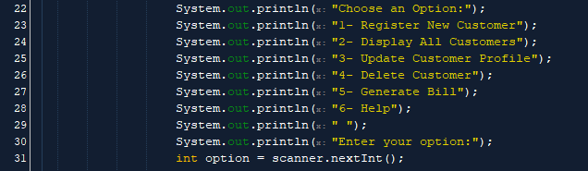

Figure 1

## **Login**

You will need to create text file before creating this software. These text files are called. The login txt file should provide the user's password and user name. Insert the text file and the paragraph breaks really are important. Paragraph 11 to 16 here shows that the login txt file has been successfully inserted.

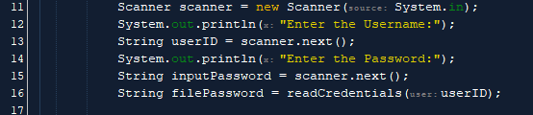

Figure 2

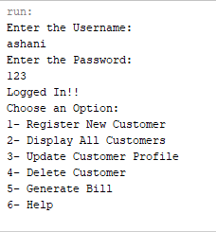After launching this Java software, the user must provide the username and password that will be used. After entering the password and username, you will be logged in an

Figure 3

If the user does not enter the correct password and username then none of the existing options can be accessed. It shows

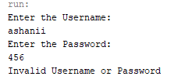

Figure 4

## **Register New Customer**

This Java program starts showing all the functions after logging in. There we will be shown Function 6 and then we have to go to the existing Register A New Customer. To access it, you have to enter the number corresponding to the function in the Enter your option field. After entering Register A New Customer, all the information will come in order. First you have to enter the first name and last name of the new customer in Register A New Customer. The customer's contact number must then be entered, followed by the address and the account number associated with them

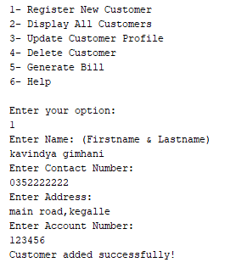

Figure 5

## **Display All Customer**

Option 2 represents the details of all the customers. This shows the data of all the users included in this Java program and to view the data, you need to enter the corresponding number in the Enter your option function. It shows the account number, account owner name, customer address and telephone number of all the customers entered there.

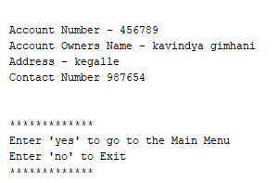

Figure 6

It is shown by the image above. Enter (yes) to go back to the menu and leave (no) to exit the program

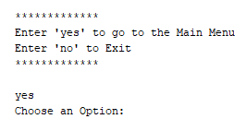

Figure 7

Enter (yes) to go back to the menu and leave (no) to exit the program

## **Update Customer profile**

The Update Customer function number is 3. After entering the number 3 in your option, you need to enter the account number of the desired customer. After entering the customer's account number, the relevant customer's account number, customer name, address and mobile phone number and using voice minutes and data usage will be displayed. Finally, the address is entered and then a message like this (Customer Information Updated Successfully!!!)

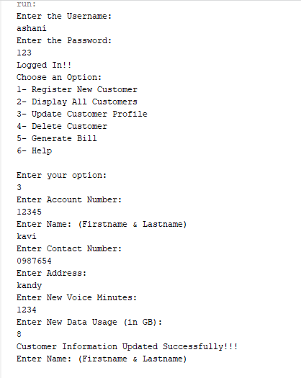

Figure 8

## **Delete Customer Profile**

Delete Customer the number corresponding to that function is 4. Enter the command into your option and it will enter into the Delete Customer. Once it is included it is necessary to delete all the information of the customer. For that you have to enter the customer account number of the relevant customer. A message like this (Customer Removed!!!) will be successfully deleted once the valid account customer number is entered.

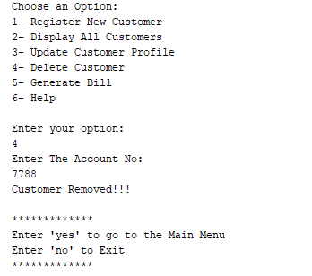

Figure 9

This is what happens when an account number is entered incorrectly (The Customer Account Number is Incorrect Please Check Again!).

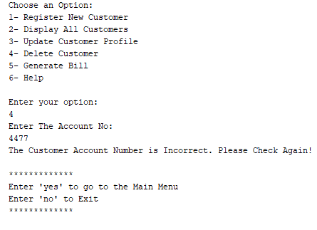

Figure 10

A message will appear below for this delete customer exit. A message like this will appear asking you to exit the function. Enter (yes) to go back to the menu and leave (no) to exit the

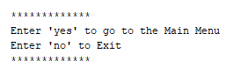

Figure 11

## **Generate Bill & Display It**

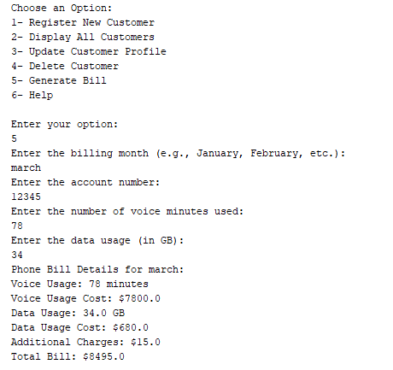

Figure 12

Here the option of generate bill is indicated by number 5. This section shows how to generate bill.

When option 5 is selected enter the month, enter the account number, enter voice usage and data usage display it when the phone bill details for that month will be calculated and the information will appear below

## **Help**

10 function is help. After giving 10 to 'Enter your option' you will be able to tell the existing problems

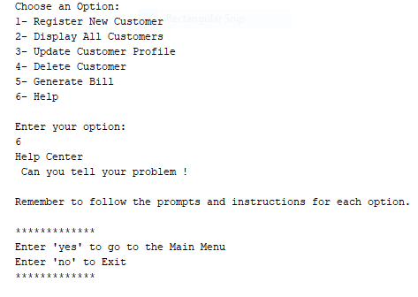

Figure 13

A message like this will appear asking you to exit the function. Enter (yes) to go back to the menu and leave (no) to exit the program

# TESTING

## Login testing

|  |  |  |  |  |  |
| --- | --- | --- | --- | --- | --- |
| Description | steps | Test data | Expected result | Actual result | Pass/ fail |
| Check the login with valid username and password | 1. Type the user’s name 2. Type the password | 1. User name-ashani 2. Password -123 | Login must be success | Login in successfully | pass |
| Check the login with invalid username and valid password | 1. Type the user’s name 2. Type the password | 1. User name-   Ashana   1. Password-123 | Login will give the error message (“invalid username or password”) | Received error message | pass |
| Check the login with a valid username and invalid password | 1. Type the user’s name 2. Type the password | 1. User name-ashani 2. Password –   2345 | Login will give the error message (invalid user name or password) | Received error message | Pass |

## Register New customer

|  |  |  |  |  |  |
| --- | --- | --- | --- | --- | --- |
| Description | Steps | Test data | Expected result | Actual result | Pass/ fail |
| Enter the new customer name(first name and last name) | 1. Type new customer first name and last name | 1. Pathum kaluarachchi | Add must be success | Add in successfully | pass |
| Enter the contact number | 1. Type new customer contact number | 1. 0713232456 | Add must be success | Add in successfully | pass |
| Enter the address | 1. Type new customer address | 1. Main street, Kegalle | Add must be success | Add in successfully | pass |
| Enter the account number | 1. Type new customer account number   (123456789) | 1. 123456789 | Add must be success | Add in successfully | pass |

## Display all customer testing

|  |  |  |  |  |  |
| --- | --- | --- | --- | --- | --- |
| Description | Steps | Test data | Expected result | Actual result | Pass/fail |
| Display customers Account number | registered customer account number can see | 123456789 | View customer all information | All customer information can be viewed | pass |
| Display customers Owner name | registered customer owner name can see | Pathum kaluarachchi | View customer all information | All customer information can be viewed | pass |
| Display customers address | registered customer address can see | Main street Kegalle | View customer all information | All customer information can be viewed | pass |
| Display customers Contact number | registered customer contact number can see | 0713232456 | View customer all information | All customer information can be viewed | pass |

## Update customer testing

|  |  |  |  |  |  |
| --- | --- | --- | --- | --- | --- |
| Description | Steps | Test data | Expected result | Actual result | Pass/fail |
| Display Account number | Enter Account number can see | 123456789 | View customer all information | All customer information can be viewed | pass |
| Display name | Enter first name & last name can see | Pathum Kaluarachchi | View customer all information | All customer information can be viewed | pass |
| Display contact number | Enter contact number can see | 0713232456 | View customer all information | All customer information can be viewed | pass |
| Display address | Enter Address can see | Kegalle | View customer all information | All customer information can be viewed | pass |
| Display voice minutes | Enter voice minutes can see | 1024 | View customer all information | All customer information can be viewed | pass |
| Display data usage | Enter Data usage can see | 25 | View customer all information | All customer information can be viewed | pass |

## Delete customer testing

|  |  |  |  |  |  |
| --- | --- | --- | --- | --- | --- |
| Description | Steps | Test data | Expected result | Actual result | Pass/ fail |
| Check type with valid account number delete customer account | 1. Type customer account number | Customer account number-123456789 | Customer Removed !! | Delete successfully | pass |
| Check type with invalid account number delete customer account | 1. Type customer account number | Customer account number-34567890 | Delete account number will give the error (“The Customer Account Number is Incorrect Please Check Again!”) | Received error message | pass |

## Generate bill testing

|  |  |  |  |  |  |
| --- | --- | --- | --- | --- | --- |
| Description | Steps | Test data | Expected result | Actual result | Pass/ fail |
| Check type with month | 1. Type month | Type the month-january | add must be successfully | month add successfully | pass |
| Check type with account number | 1. Type customer account number | Customer account number-123456789 | add must be successfully | Account number added successfully | pass |
| Type the number of voice usage | 1. Type the voice usage | Enter the use voice minutes | add must be successfully | add successfully | pass |
| Type the number of data usage | 1. Type the Data usage | Enter the use Data usage (GB) | add must be successfully | add successfully | pass |

## Help testing

|  |  |  |  |  |  |
| --- | --- | --- | --- | --- | --- |
| Description | Steps | Test data | Expected result | Actual result | Pass/ fail |
| Check the help message | Type the message | Type the message- “can you tell your problem “ | Must be successfully | Message send successfully | pass |

# REFERENCES

(w3school, 2023)

# CONCLUSION AND RECOMMENDATION

We have created a Java program in this software solution for Dialcom Telecommunication Provider to automate the maintenance of client accounts and billing data. Features including user identification, client registration, account details display, bill generation, and user assistance are all provided by the system. It exhibits efficient management of financial transactions and client data.

A text file called "dialcom_details.txt" contains client profiles that may be added, updated, and deleted by customers using this code. It also generates and prints customer bills with a breakdown of charges depending on phone and data usage. Billing information is kept in a different text file called "billing_records.txt". The help feature instructs users on how to utilize the system.

The Dialcom Telecommunication Provider software needs enhancements to improve functionality, reliability, and user-friendliness. Key recommendations include robust data validation, stronger security measures, transitioning to a scalable data storage solution, improving user interface, modularizing code for better readability, rigorous testing, comprehensive documentation, and implementing a version control system like Git. These measures aim to ensure the software aligns with the evolving needs of the business and its customers, ensuring the software's functionality, reliability, and user-friendliness.

# Apendix-coding

Dialcom Telecommunication Provider Some visual details of this Java operating system Basic functions and design of the program Construction and field implementation and shows all codes

## Enter user name and password coding

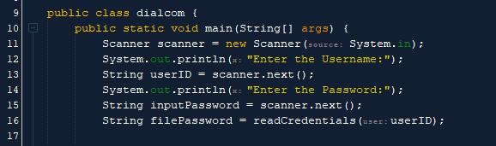

Figure 14

## Main menu coding

Figure 15

## Switch option coding

Figure 16

## Main menu exit option coding

Figure 17

## Function to check the login credential coding

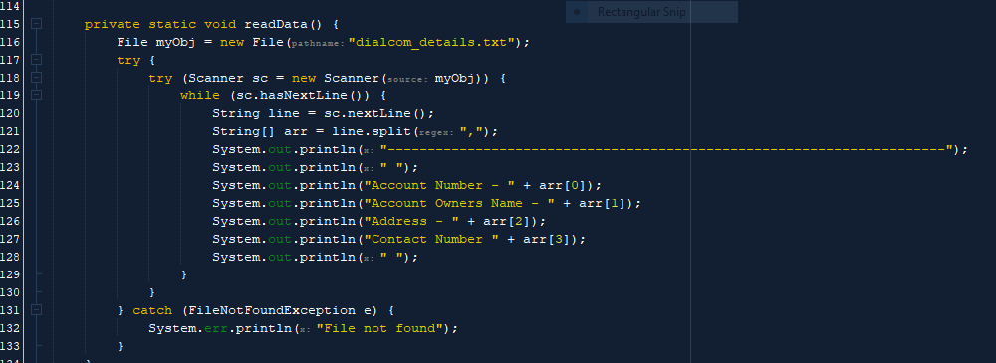

Figure 18

Add profile coding

## Add customer Profile coding

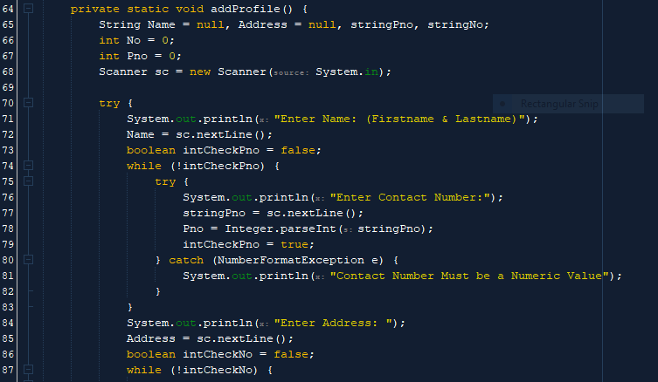

Figure 19

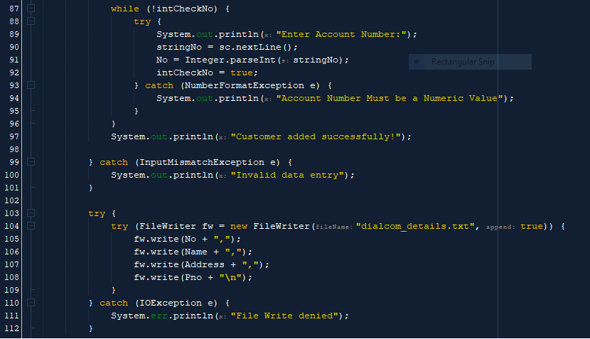

Figure 20

## Display all customer coding

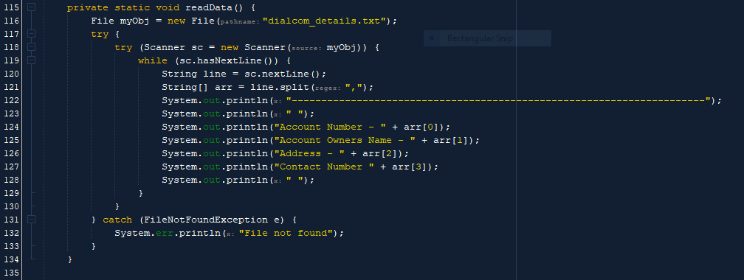

Figure 21

## Delete customer coding

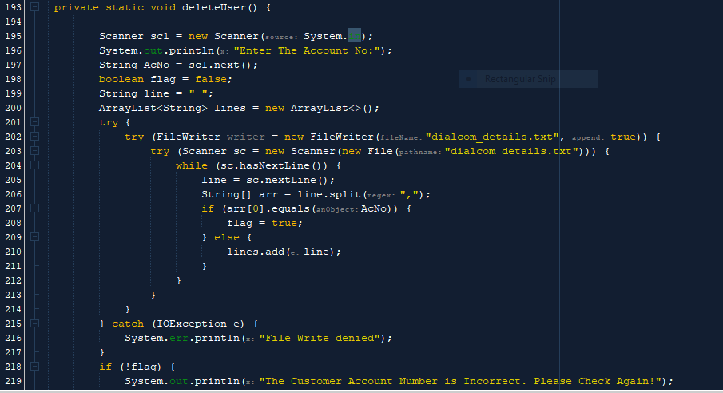

Figure 22

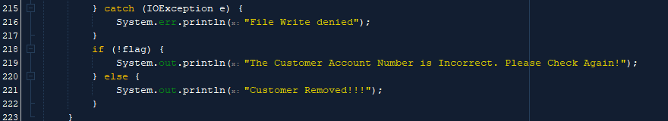

Figure 23

## Update customer option coding

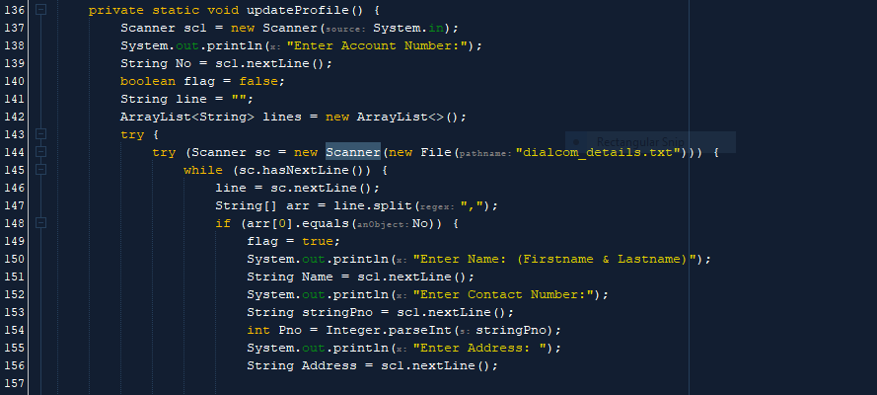

Figure 24

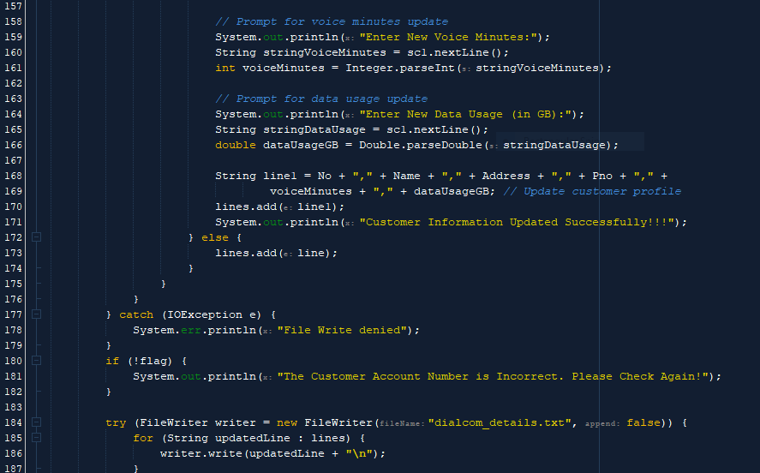

Figure 25

## Help option coding

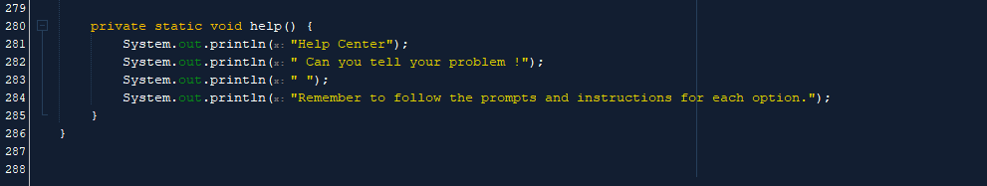

Figure 26

## Generate bill option coding

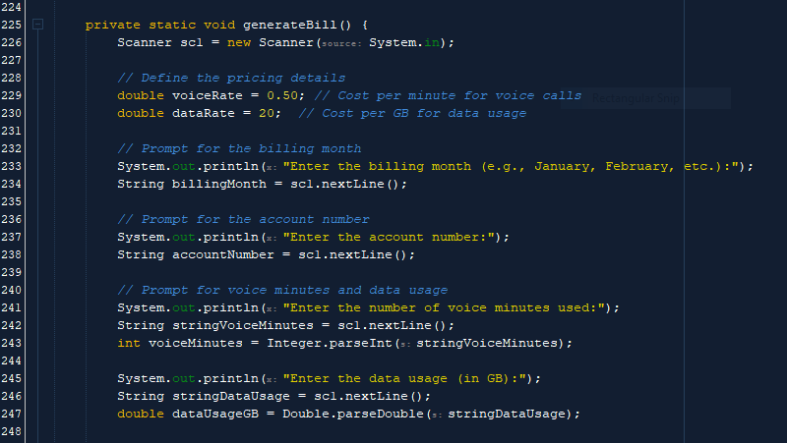

Figure 27

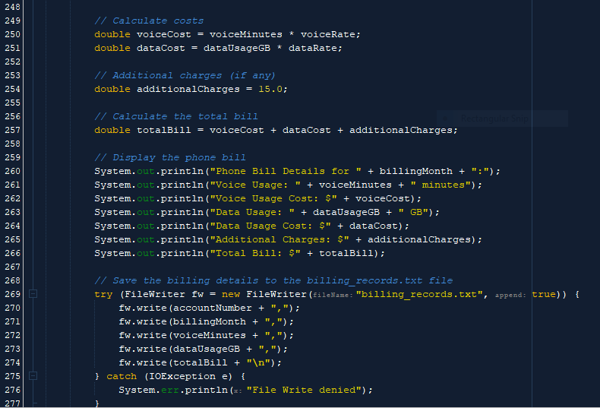

Figure 28